# **Smart-home system**

## **Lukas Žaromskis, Kipras Mikiška, Ugnius Mockus, Tomas Saročka**

Inconveniences like incorrect lightning or temperature can be an irritating factor for people at work and in everyday life. Variation in these conditions could cause eye strain, stress and many other negative effects. The Smart-home system allows to monitor and control any rooms luminosity and temperature levels using a simple phone application and sensors installed in the rooms. To demonstrate this study a virtual room with sensors will be created using the Unity engine.

## **1. Introduction**

The importance of good lighting cannot be stressed enough. Adequate Lighting makes the room look bigger and casts attractive shadows around the room. Poor lightning can affect people In a variety of different ways that harm health (heat stress, musculoskeletal disorders) may affect the performance of a person; effects that decrease the capacity of the individual to perform a task (poor lighting, distraction); effects that trigger frustration, resistance to change and uncooperative attitudes. Good lighting can come from any light source.

One of the fundamental properties of the indoor climate is temperature. It can be controlled with a degree of accuracy depending on the room and its temperature control system. Several human responses are influenced by the indoor temperature including thermal comfort, perceived air quality, sick building syndrome and most importantly performance while working.

People are always looking for a way to make their lives as comfortable and efficient as possible in the easiest way they can find. The smart-home system provides a way to reach maximum comfort or work efficiency without having to get up from the bed or chair. The Smart-home system allows to monitor and control any rooms luminosity and temperature levels using a simple phone application and sensors installed in the rooms.

The paper is structured as follows A review of the related research work is described in Section 2. The smart home systems Framework and architecture is defined in section 3. The developed prototype, Simulations and experimental results are presented in Section 4.

## **2. Related research work**

Lighting should be designed to provide people with the right visual conditions that help them to perform visual tasks efficiently, safely and comfortably. The luminous environment acts through a chain of mechanisms on human physiological and psychological factors, which further influence human performance and productivity [1]. Appropriate lighting, without glare or shadows, can reduce eye fatigue and headaches. Good quality lighting also reduces the chance of incidents and injuries from "momentary blindness" (momentary low field vision due to eyes adjusting from brighter to darker, or vice-versa, surroundings) [2].

The most important vital factors that influence the efficiency of office staff are the indoor room temperature and lighting. The efficiency of office staff was impaired by the thermal discomfort caused by elevated air temperatures. The building's environmental quality has influence on the office workers' Performance [3].

Office staff that spent 90% of their time in an indoor climate. The environment is directly linked to the health and well-being of the office worker. By acquiring the most optimal temperature, the performance of workers increased by 10 percent [4].

## **3. Framework architecture**

Smart-home system is a smart system to keep luminosity and temperature and desired levels. Parts that are included are: light sensor, camera, switches/dimmers, blinds, heaters, controller. The experiment will be simulated using a virtual room and sensors. Also a simple mobile application, both of these will be created using the “Unity” engine.

A UML use case diagram is shown in fig. 1. to describe the various use cases (processes) that a user could perform with this framework.

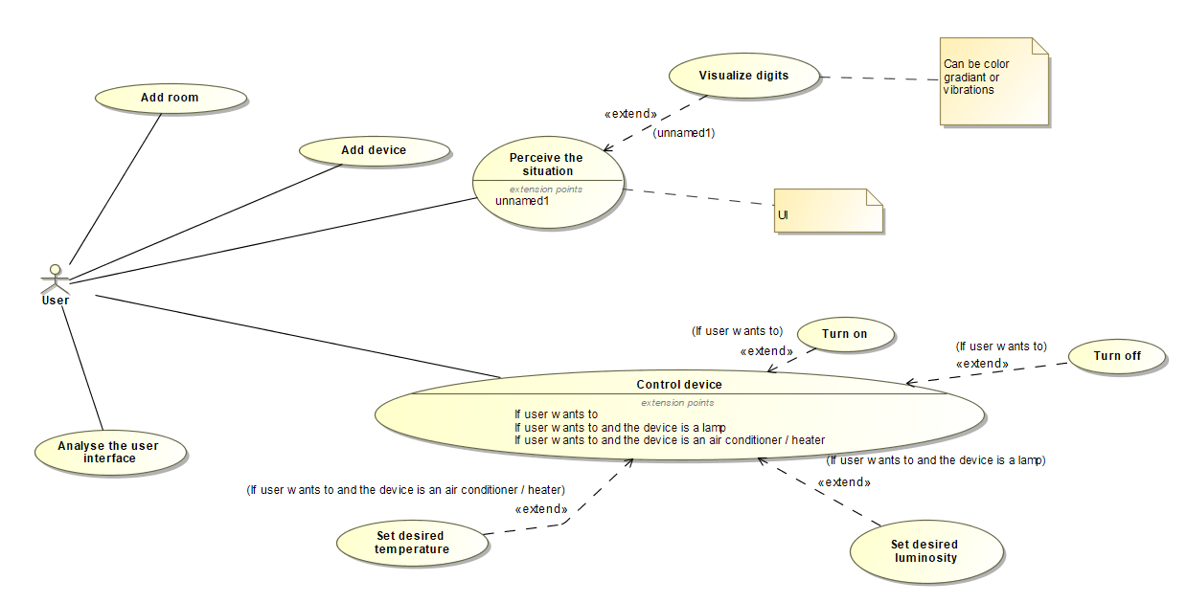

Figure 1. The considered use case diagram

A UML class diagram is shown in Fig. 2 it is a type of static structure diagram that describes the structure of a system by showing the system's classes, their attributes, operations (or methods), and the relationships among objects.

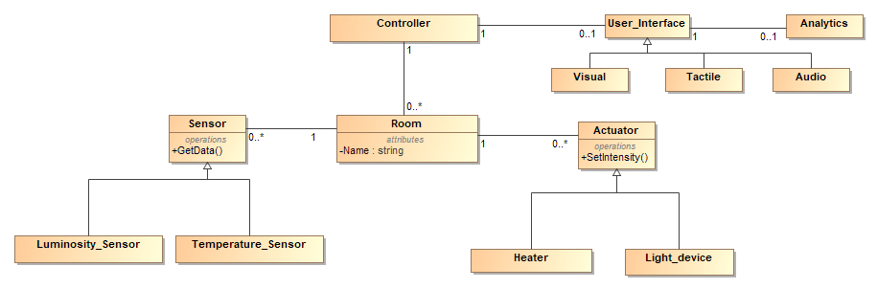

Figure 2. the considered class diagram

A UML state machine diagram is shown in fig. 3 State Machine Diagram (or sometimes referred to as state diagram, state machine or state chart) shows the different states of an entity. State machine diagrams can also show how an entity responds to various events by changing from one state to another. State machine diagram is a UML diagram used to model the dynamic nature of a system.

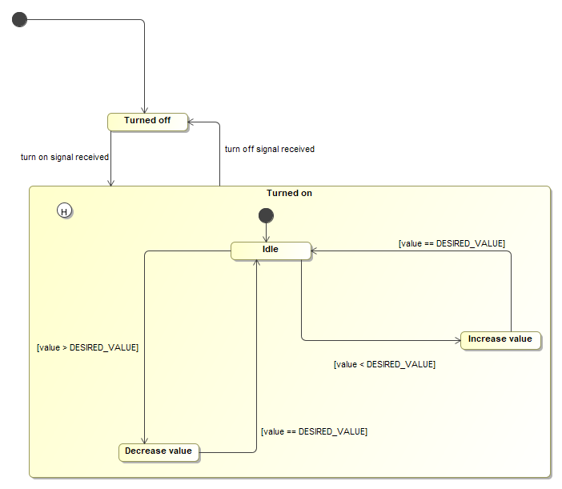

Figure 3. the considered state machine diagram

## **4. Simulations and experimental results**

A simulation was carried out to test the proposed system. The scenario of the simulation is as follows:

* The desired room is chosen by the user using the mobile application Fig.4
* User is then presented with an option to choose the desired luminosity and temperature. Fig.5

As the simulation is running, the user can change his desired settings and observe the changes in real time.

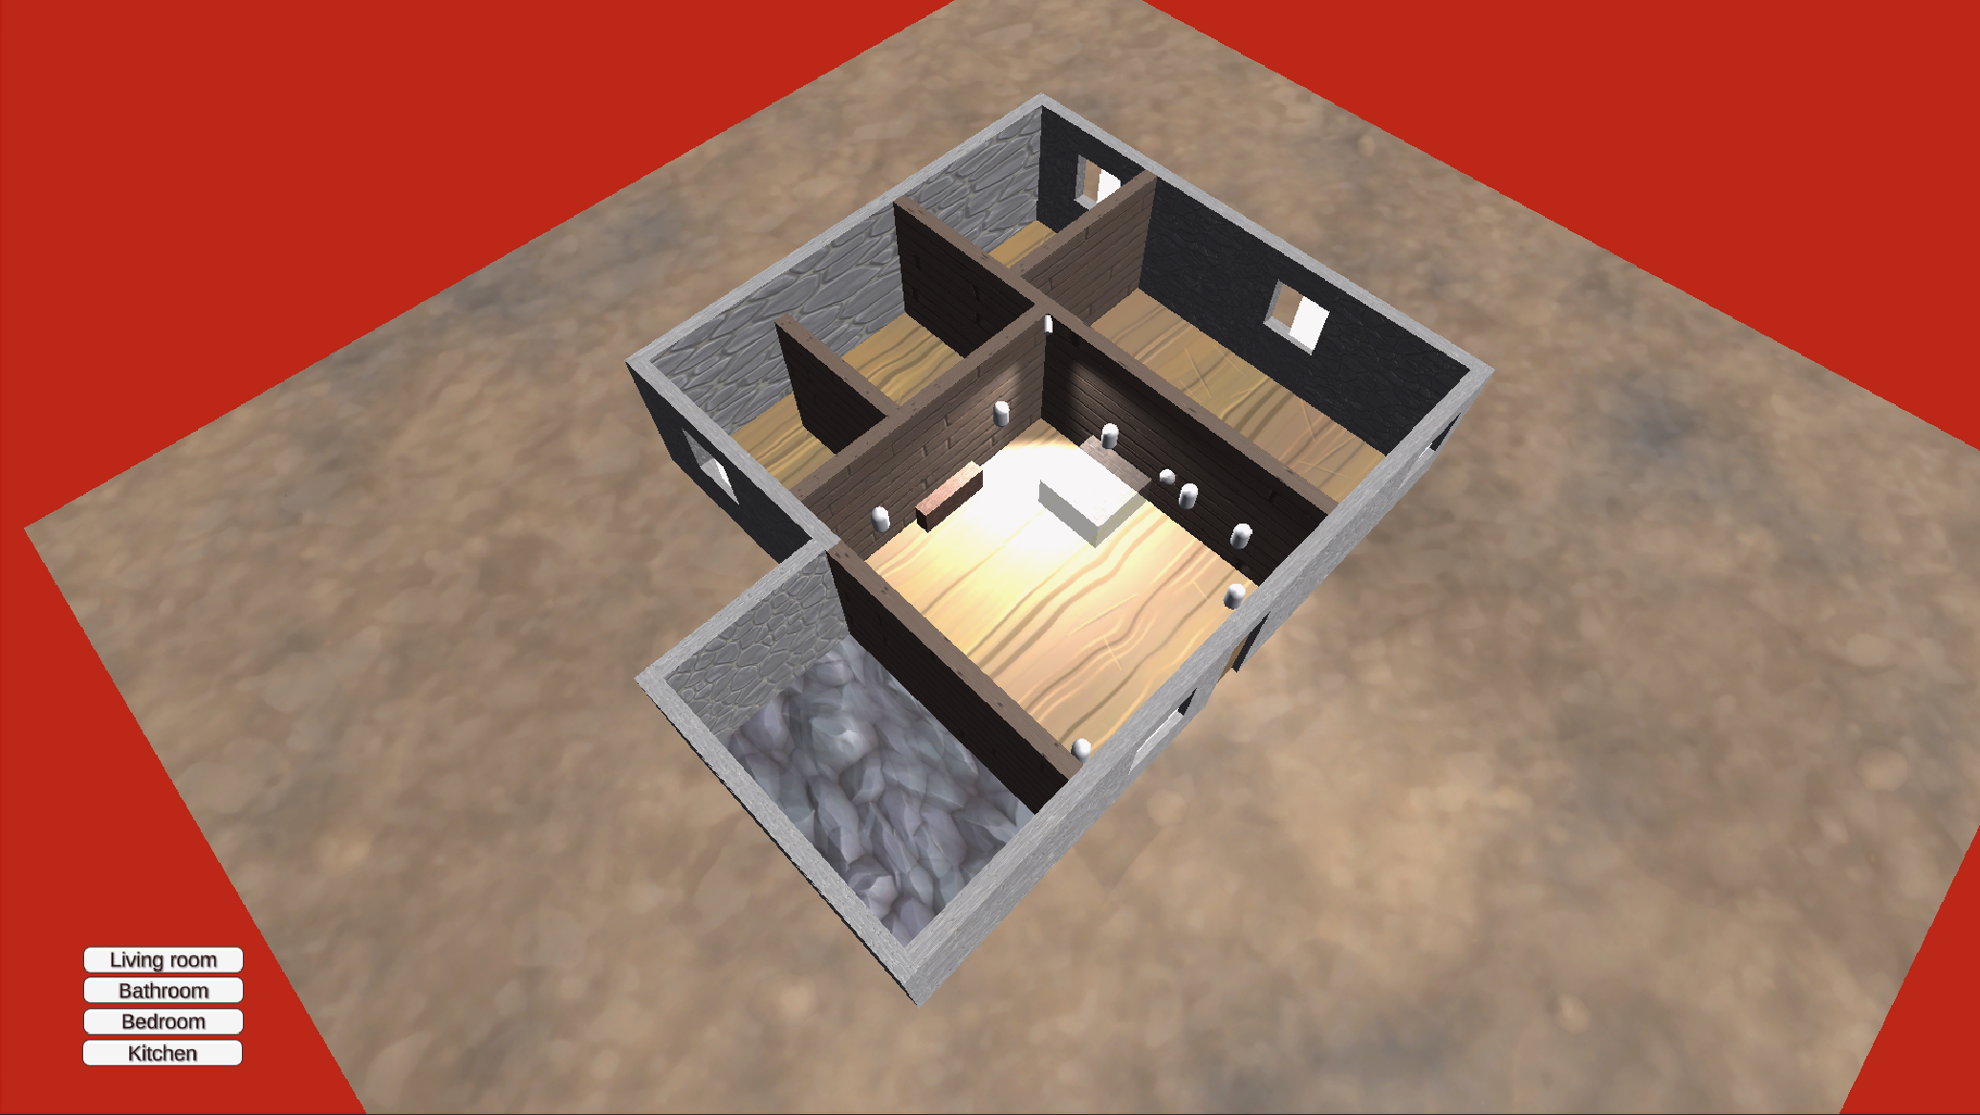

Figure 4 user interface for choosing a room

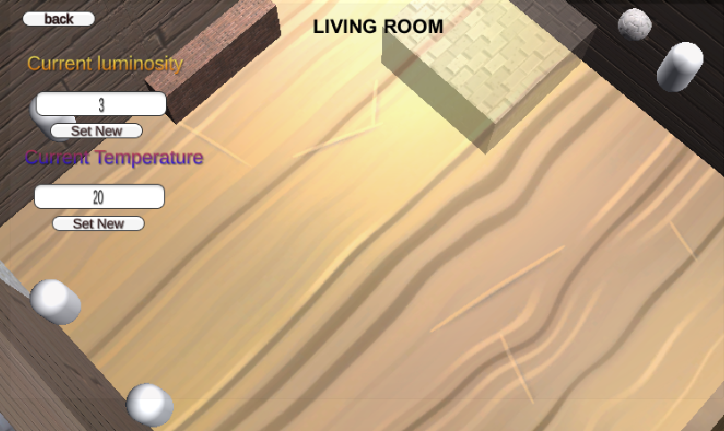

Figure 5. User interface for choosing luminosity and temperature

The light sensor reacts to the level of ambient light. Using light level readings from the sensor and the user's chosen luminosity level the program calculates and changes the lights luminosity.

The temperature sensor reacts to the level of current temperature. Using temperature level readings from the sensor and the user's chosen temperature level the program calculates and changes the temperature.

# 

# Assessment

Current User interface is extremely simple and easy to use, but every design can be improved:

To make the user interface more compatible for people with disabilities it would be appropriate to add haptic and audio feedback. Another point that would make this interface more fluid and easier to use would be to change the way a user selects luminosity levels (change the textbox to a slider).

## **References**

1. **Gligor, V.: Luminous Environment and Productivity at Workplaces. Thesis (2004). Espoo:Helsinki University of Technology.**
2. **Canadian Centre for Occupational Health & Safety. “Lighting Ergonomics.” ccohs.ca, https://www.ccohs.ca/oshanswers/ergonomics/lighting_general.html?fbclid=IwAR0zvaOxGqD6qf6vYZuMb8pHa1JUUna-CW-YVy2_bg-ZumI3wICnRSvF9Qs#:~:text=Appropriate%20lighting%2C%20without%20glare%20or,machinery%20and%20other%20safety%20hazards.**
3. **Lan L, Wargocki P, Lian Z. Quantitative measurement of productivity loss due to thermal discomfort. Energy Build. 2011;43:1057–1062. doi: 10.1016/j.enbuild.2010.09.001. [[CrossRef](https://dx.doi.org/10.1016%2Fj.enbuild.2010.09.001)] [**[**Google Scholar**](https://scholar.google.com/scholar_lookup?journal=Energy+Build&title=Quantitative+measurement+of+productivity+loss+due+to+thermal+discomfort&author=L+Lan&author=P+Wargocki&author=Z+Lian&volume=43&publication_year=2011&pages=1057-1062&doi=10.1016/j.enbuild.2010.09.001&)**]**
4. **Roelofsen P. The impact of office environments on employee performance: the design of the workplace as a strategy for productivity enhancement. J Facil Manag. 2002;1(3):247–64. [**[**Google Scholar**](https://scholar.google.com/scholar_lookup?journal=J+Facil+Manag&title=The+impact+of+office+environments+on+employee+performance:+the+design+of+the+workplace+as+a+strategy+for+productivity+enhancement&author=P+Roelofsen&volume=1&issue=3&publication_year=2002&pages=247-64&)**]**